A Hypothetical Example of the DAVID Clustering
Raw Data
Table 1. Profile of genes vs. terms
 | t1 | t2 | t3 | t4 | t5 | t6 | t7 | t8 | t9 | t10 | t11 | t12 | t13 | t14 | t15
gene a | 1 | 1 | 1 | 1 | 1 | 1 | 1 | 1 | 1 | 1 | 0 | 0 | 0 | 0 | 0
gene b | 1 | 1 | 1 | 1 | 1 | 1 | 1 | 1 | 1 | 1 | 0 | 0 | 0 | 0 | 0
gene c | 1 | 1 | 1 | 1 | 1 | 1 | 1 | 1 | 1 | 1 | 0 | 0 | 0 | 0 | 0
gene d | 0 | 0 | 0 | 0 | 1 | 1 | 1 | 1 | 1 | 1 | 1 | 0 | 0 | 0 | 0
gene e | 0 | 0 | 0 | 0 | 0 | 1 | 1 | 1 | 1 | 1 | 1 | 1 | 1 | 1 | 1
gene f | 0 | 0 | 0 | 0 | 0 | 1 | 1 | 1 | 1 | 1 | 1 | 1 | 1 | 1 | 1
gene g | 0 | 0 | 0 | 0 | 0 | 1 | 1 | 1 | 1 | 1 | 1 | 1 | 1 | 1 | 1
gene h | 0 | 0 | 0 | 1 | 0 | 0 | 0 | 1 | 0 | 0 | 0 | 1 | 0 | 0 | 0

Visually, gene a, b, and c share similar profile of terms. Gene e, f, and g have common profile. Gene d could be in either groups. Gene h (yellow) is an outlier not closely associating with any of the groups. Therefore, there are two major gene groups (blue and red), and gene d (green) could belong to either groups.
Goal
Based on the given profile of terms, to systematically determine the number of potential gene groups and classify genes into each group.
DAVID Clustering: A Heuristic Multiple Linkage Fuzzy Clustering Procedure
Step 1: Measure the relationships of all gene-gene pairs with Kappa statistics (Table 2) (or any distance measurement). A heuristic threshold of kappa value is 0.35 (i.e. 'Kappa similarity' threshold in DAVID interface). Any values above it (in red) are considered as significant relationships.
Table 2. The relationships of all gene-gene pairs with Kappa statistics
 | a | b | c | d | e | f | g | h
a |  | 1 | 1 | 0.35 | -0.50 | -0.50 | -0.50 | 0.00
b | 1 |  | 1 | 0.35 | -0.50 | -0.50 | -0.50 | 0.00
c | 1 | 1 |  | 0.35 | -0.50 | -0.50 | -0.50 | 0.00
d | 0.35 | 0.35 | 0.35 |  | 0.35 | 0.35 | 0.35 | -0.11
e | -0.50 | -0.50 | -0.50 | 0.35 |  | 1 | 1 | 0.00
f | -0.50 | -0.50 | -0.50 | 0.35 | 1 |  | 1 | 0.00
g | -0.50 | -0.50 | -0.50 | 0.35 | 1 | 1 |  | 0.00
h | 0.00 | 0.00 | 0.00 | -0.11 | 0.00 | 0.00 | 0.00

Step 2: Create qualified initial seeding groups: Each gene could form a initial seeding group (initial seeds) as long as it has close relationships (e.g. kappa >= 0.35) with more than >2 other members (i.e. 'initial group membership' threshold in DAVID interface). In order to control the quality of the seeding groups, the qualified seeding groups (qualified seeds) need to meet the second condition, i.e. majority (>50%) of members in the seed should have close relationships (e.g. kappa >= 0.35) each other. For example, 'd->a b c e f g' is not qualified because too many (>50%) gene pairs like a-e, a-f, a-g, b-e, b-f, b-g, etc. do not show good relationships (e.g. kappa < 0.3). Therefore, 'd->a b c e f g' and 'h->' do not meet above two heuristic conditions.

Initial seeds | # of membership | % of tighter relationships (>0.35) within a seed | Qualified seeds
a-> b c d  b->a c d  c->a b d  d->a b c e f g  e->d f g  f-> d e g  g-> d e f  h-> | >2  >2  >2  >2  >2  >2  >2  <2 | >50%  >50%  >50%  <50%  >50%  >50%  >50% | 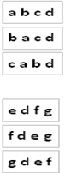

Step3: Iteratively merging above qualified seeds: Any two seeds have chances to be merged if they share majority (e.g. >50%) of members (i.e. 'Multiple Linkage' threshold in DAVID interface). For example, 'abcd' and 'bacd' are merged due to sharing 100% members in loop No. 1. Merging keep going until all groups are stable, i.e. no two seeds and intermediate groups share more than >50% members. The dash lines represent the stop points to start next new loop.
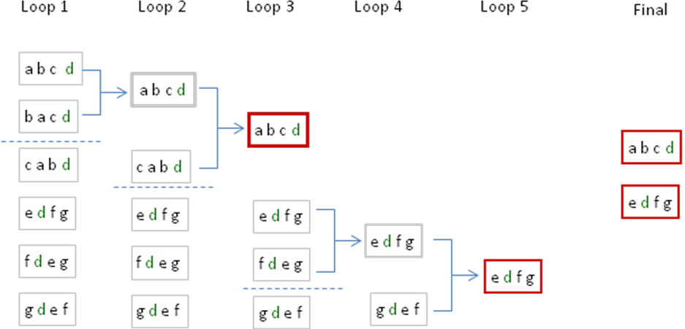

Result
Two gene groups are discovered, 'abcd' and 'efgd'. Gene d (in green) is assigned to two groups respectively. Gene h is an outlier. Results are consistent with human visual judgment at beginning.
Key Points
- Number of total groups is dynamically determined based on the given conditions.
- Fuzziness: one member could be in more than one groups, e.g. gene d is in both groups.
- Outliers are filtered out, e.g. gene h.
- Method could be expanded to other applications, such as microarray expression clustering.

